“Investment Policy Statement
Student’s Name
Institution Affiliation
Date”

“Investment Policy Statement”
“Scope and Purpose Context”
“This policy statement seeks to develop and determine a plan for the growth of an investment portfolio for Brian and Katie Taylor, Joint Investor, age 60 and 52. Investments are expected to run in the long-term through the gradual multiplication of the value and output. Most importantly, the creation of this policy will sustain the development of an individual business with the potential of turning into a family business that will engage in various activities in the consumer market. Investor the components under this investment policy statement will exclusively integrate all the portfolios belonging to Brian and Katie Taylor, registered in her name. It will also include portfolios registered with joint ownership rights with an individual of her choice and any other accounts created by Brian for her own benefit and that of her family.”
“Structure”
“Brian and Katie Taylor, the investment advisor will serve the purpose of reviewing and recommending the allocation of asset classes with critical consideration of the range. The advisor will also provide objective professional guidance as a third-party with the aim of providing assistance in the management of all investment activities. It will also be the duty of the advisor to ensure that ethical investment practices are adopted to avoid any actions that my compromise the well-being of the portfolio.”
“Other duties to be administered by Brian and Katie Taylor, will include:”
“• Selection of investment options
• Supervising the activities of investment partners
• Accounting and managing expenditure under the portfolio”

“Governance”
“ a. The duty of approving the investment policies will be performed by executive board of the Walter Trust Associates, which will also evaluate the merits of any subsequent changes to the policy. On the other hand, Brian and Katie Taylor, will have the authority to recommend any changes in the investment policy.
B. Charles Wentworth will have exclusive responsibility of closely evaluating and monitoring the investments under this portfolio, particularly with regard to any potential circumstances that may impact the portfolio. Following the evaluation, Wentworth will provide recommendations to the board of executives of the Walter Trust Associates for further evaluation.
c. Brian and Katie Taylor, will have the authority to determine engagement with external individuals or companies. His conduct will be evaluated based on reports and communication with Tina Lawson.
d. The duty of determining asset allocation and inputs for investment will be handled by Brian and Katie Taylor, on behalf of the executive board of the Walter Trust Associates. In this regard, Taylor will be expected to present rationale for the proposed investment strategies to the client and board.
e. Brian and Katie Taylor, will utilize statements issued by investment partners to assess risk for this account. Smith will work with the risk assessment team to determine the risk levels and come up with recommendations for mitigation.”
“Investment Return, and Risk Objectives”
“A. The objective of this IPS is to sustain and grow the assets for Brian and Katie Taylor, in the long-term and provide security during retirement.”
“B. Brian and Katie Taylor, balance sheet is the source of much concern owing to the amount of liabilities compared to assets. Investment in stocks and bonds in the local and international money markets will shift the balance between the assets and liabilities. The future annual return for the portfolio can be expected at 8.1 percent and inflation at 2.5 percent. Considering tax deductions the portfolio, the owner can receive 1.1 percent share.”
“c. Based on the investor’s knowledge of the stock and bonds market, she has confidence in investment as indicted by the score of 33 showing high tolerance for risk.”
“d. The client requires some level of security and, as a result, she requires that besides the annual paid returns being sent to her savings account, 10 percent of the portfolio should remain withdrawable within the a week’s period upon the issuance of a notification.”
“e. Brian and Katie Taylor, is still single and with no children, which implies that the conditions guiding this IPS are subject to change in the future.”
“f. Asset Allocation”
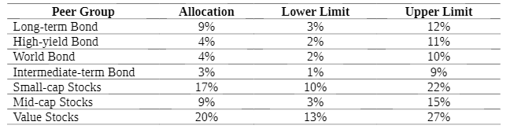
“f. Expected Returns”

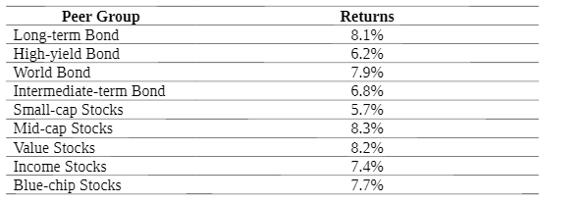

“Risk Management”
“ a. The board of executives will evaluate the status of the portfolio and provide information to the investor using the Global Performance Standards. Lawrence Smith will be integral in providing the performance reports for this particular account for compilation in a quarterly basis.
b. Like the performance reports, risk assessment and benchmark information about the portfolio will be prepared by the board of executives for the Walker Trust Associates and presented to the investor on a quarterly basis.
c. Rebalancing of the portfolio will be done by consideration of the incoming cash flows as indicated by the quarter reports. Basic parameters to apply here will include the target weighing per asset class and any positive of negative changes therein”

